Desafio processo seletivo Híbrido

1 - Realizado a instalação e configuração do Magento 2 via docker:

Installation Guide
- Clone the magento-docker-compose repository by executing the following command in the working directory:
git clone https://github.com/haroldoramirez/magento-docker-compose <name folder>
- Go into the folder
cd <name folder>
- Edit the docker-compose.yml file
vi docker-compose.yml
- Start editing in VIM press 'i'
- Replace 'magento002' with magentodemo
:%s/old/new/g (replace all old with new throughout file)
:%s/magento002/magentodemo/g
- Save and quit VIM
:wq
- Run Docker (this will create/pull the images)
docker-compose up -d
- View the current containers
docker ps

Setup Magento
- Go to the browser and type the following:
localhost:8002/setup
- Click on the 'Agree and Setup Magento' button

Magento Setup Wizard
- Click on the 'Start Readiness Check' button
This will check your PHP version, settings, extensions and file permissions

click 'next'

- Add a database
Database Server Host -> db
Database Server Username -> root
Database Server Password -> root
Database Name -> magentodemo
Table prefix (optional) -> (leave empty)
click 'next'

- Web cofig
Your Store Address -> http://localhost:8002/ (already predefined)
Magento Admin Address -> http://localhost:8002/(adminlink) (also predefined)
click 'next'

- Customize your store
Store Default Time Zone -> "choose your timezone"
Store Default Currency -> "choose your currency"
Store Default Language -> "choose your default language"
click 'next'

- Create admin account
New Username -> "choose a username"
New Email -> "fill in an emailaddress"
New Password -> "choose a password"
Confirm Password -> "confirm the password"
click 'next'

- READY! Click on the 'Install Now' button

Success
Please keep this information for your records:

Magento Admin Info:

Username:
haroldoramirez

Email:
haroldoramirez@gmail.com

Password:
******

Your Store Address:
http://localhost:8002/

Magento Admin Address:
http://localhost:8002/admin_b3ydcv/

Be sure to bookmark your unique URL and record it offline.

Encryption Key:
8aa6bcb5e488533fde01e101df648abf

Database Info:

Database Name:
magentodemo

Username:
root

Password:
root

For security, remove write permissions from these directories: '/var/www/html/app/etc'

Imagens

1
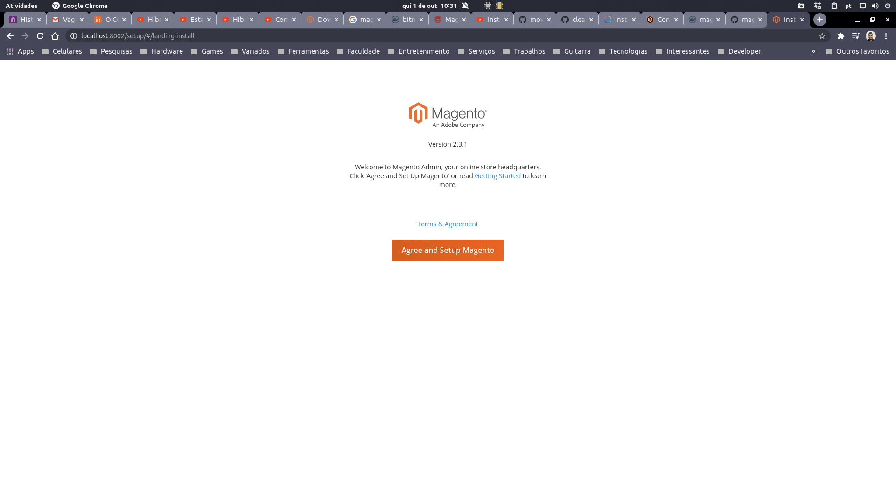

2
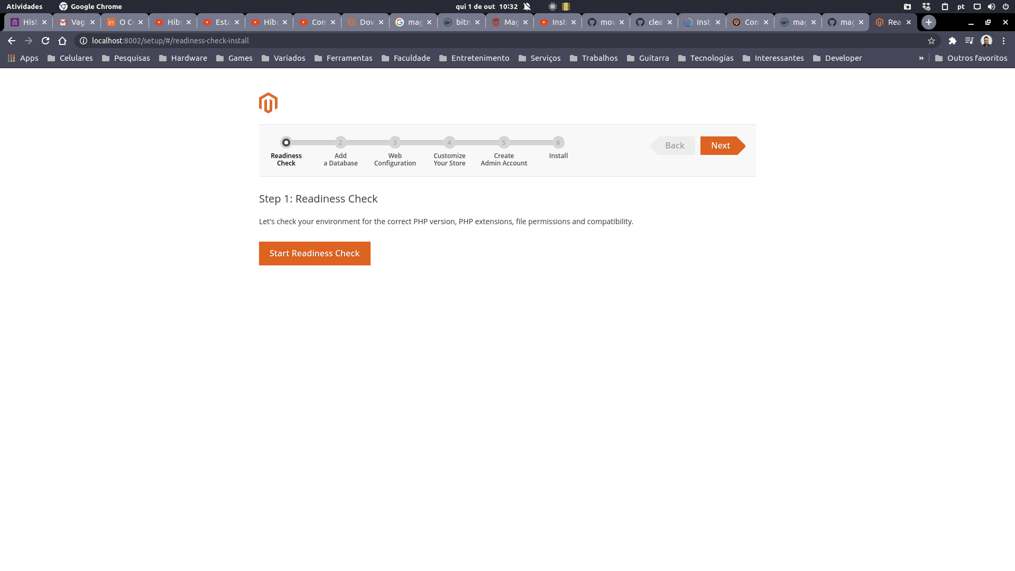
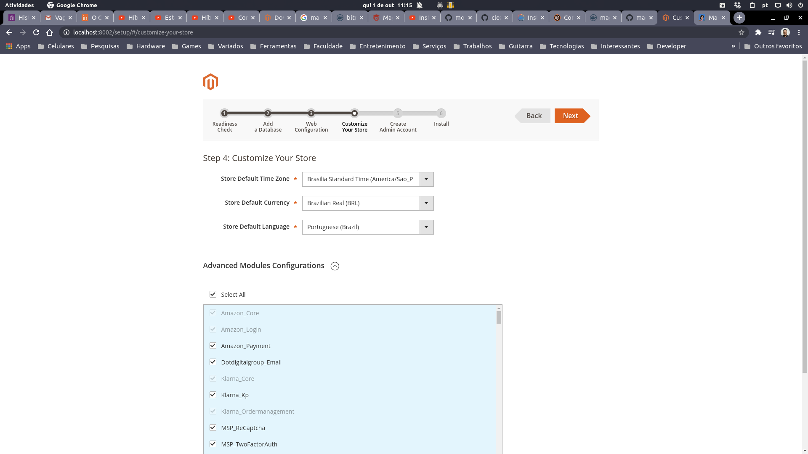
3
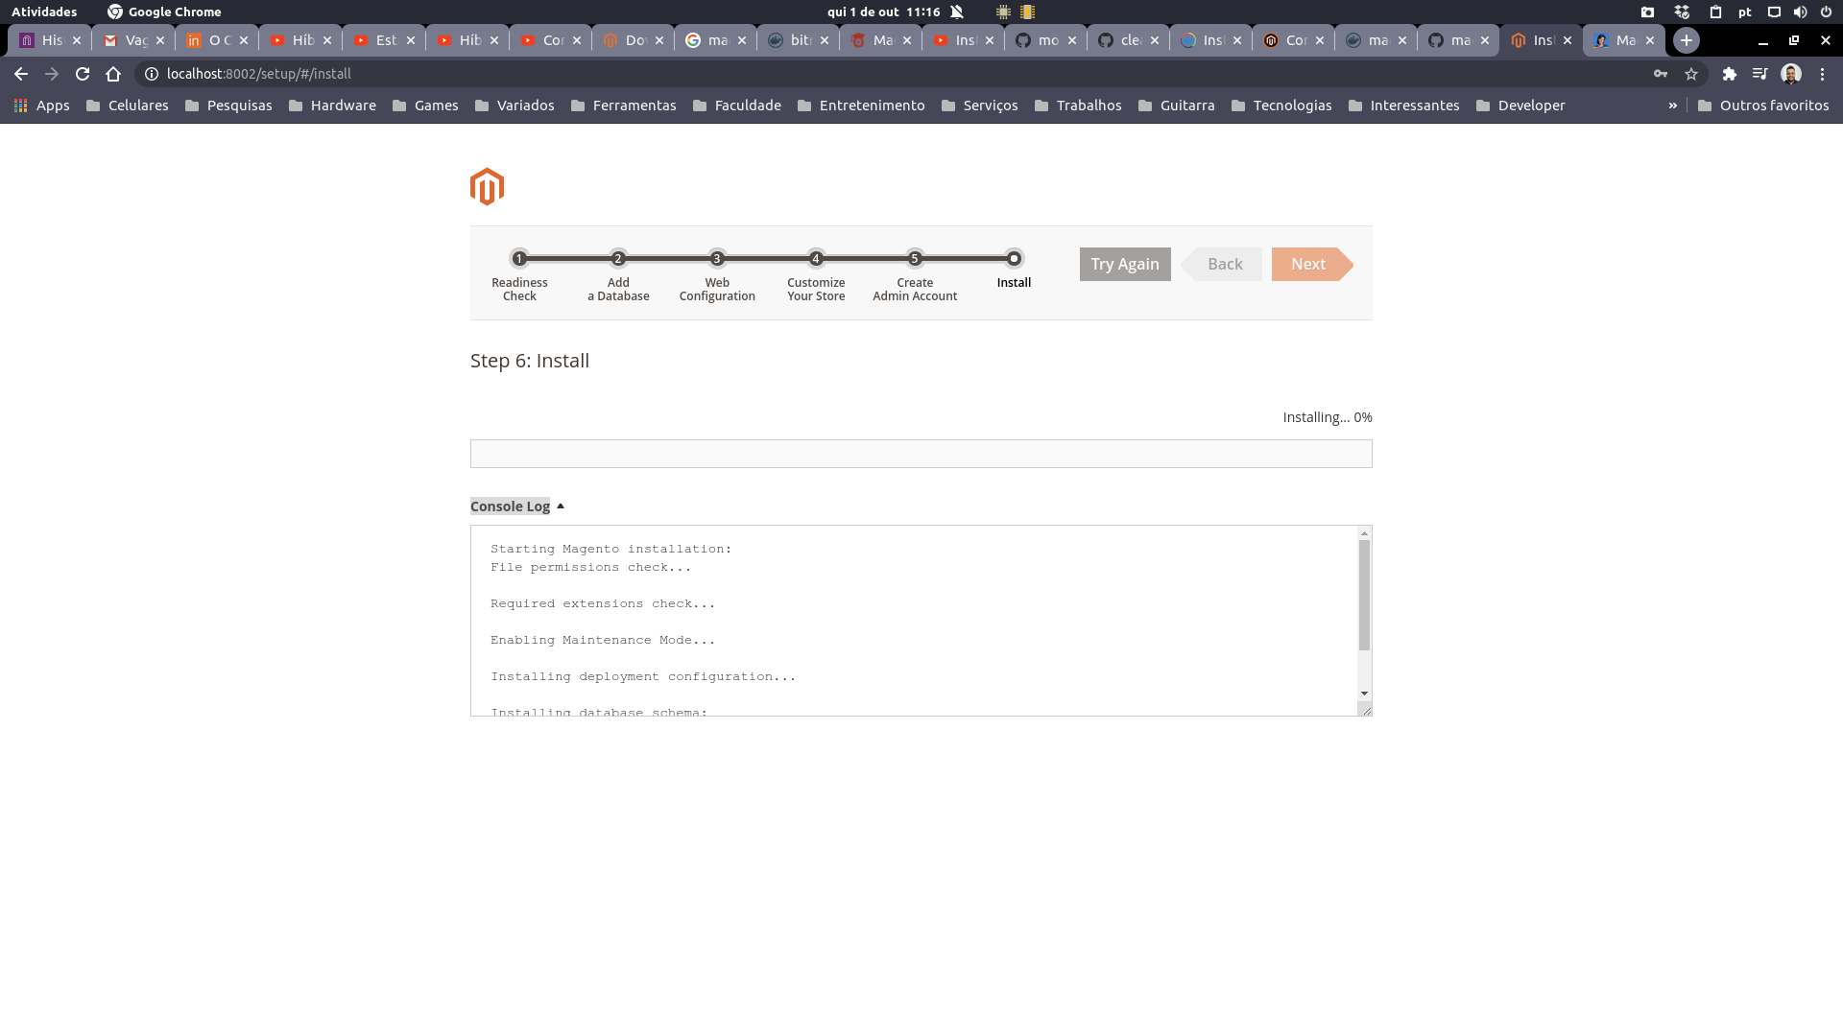
5 - Success
